Autonomous control of drone using optical flow of features in concrete - Guide

To establish connection with drone “bebop_autonomy” has been used. All files created have been created in a package. Furthermore, a launch file, to enable automatic launch of all files, except the ‘drone_cam_sub’, has been developed.

The four programs created can be seen on the following figure denoting the connection between those. Note that the target tracking is also responsible for the distance estimation

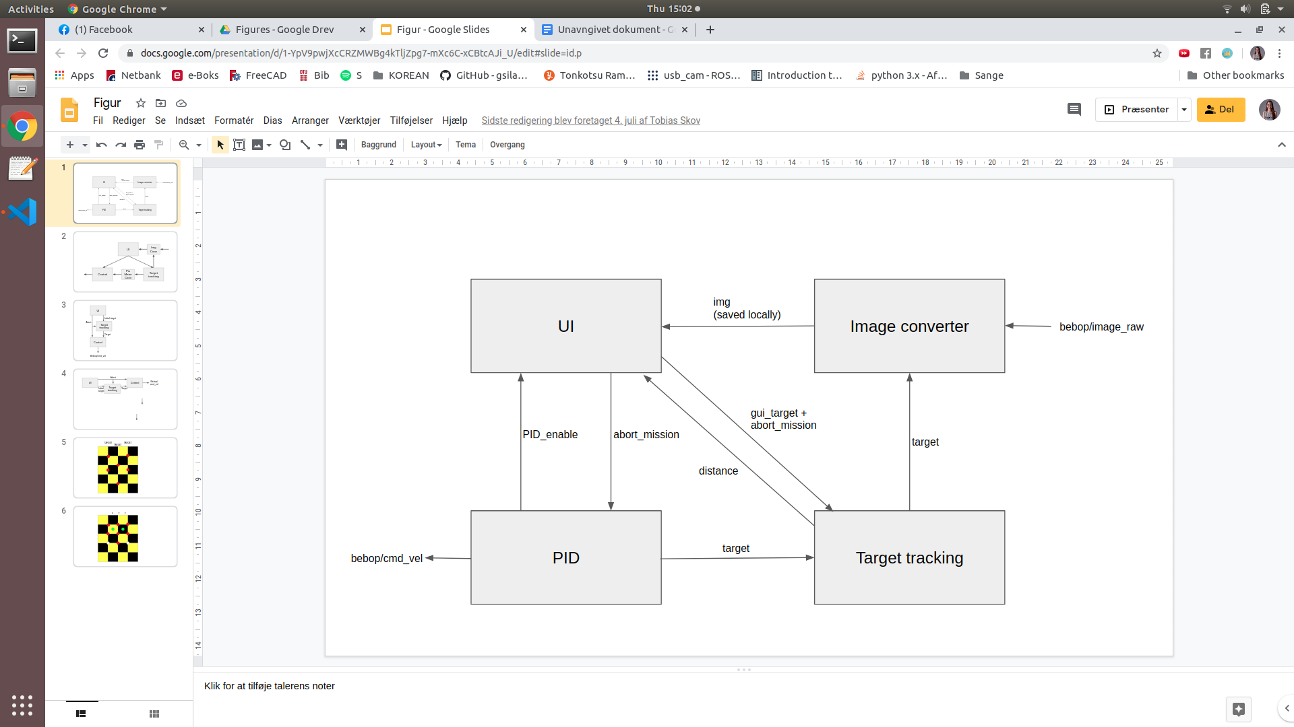

The four programs are placed in a user-made package. The following link describes how to generate a package

<http://wiki.ros.org/ROS/Tutorials/CreatingPackage>

Sometimes, depending on the computer, the computer wasn’t able to find the files. A solution that worked for us was by typing in the workspace

$ echo LD_LIBRARY_PATH=~/bebop_ws/devel/lib/parrot_arsdk:$LD_LIBRARY_PATH >> ~/.bashrc

For a workspace called ‘bebop_ws’ (and remember to source devel/setup.bash afterwards)

Also, there was some issues with a misplaced folder. This may be solved using the following steps:

* First of all, go to ‘Other locations -> Computer -> opt -> ros” and copy the folder “parrot_arsdk”
* The folder needs to be placed in bebop_ws/devel/lib

The launch file should be placed in the folder src\bebop_autonomy\bebop_tools\launch, and can then be used by using following command:

$ roslaunch bebop_tools sensor_deploy_i.launch

As drone_cam_sub uploades an image locally it was not possible to include this file in the launch file. Therefore, this file must be run in a different terminal using:

$ rosrun [PACKAGE_NAME] drone_cam_sub.py

If wished so, the difference to target can be followed live using a rqt_plot (in a new terminal)

$ rqt_plot /error_to_target

If wished so, a program has been made, so the video from the drone is saved locally in the workspace parent folder. The program can be run by using

$ rosrun [PACKAGE_NAME] record_video.py

TIP: Remember to change the names of .csv files in move_to_target and target_tracking, and the video file from record_video, or else the previous files will be overwritten. Also, remember to make the names of the two .csv files unique, or else only one will be saved (we have done this too many times)

If needed, a guide was made early in the process for describing the process of installing bebop autonomy. The guide can be found on the following link:

<https://docs.google.com/document/d/1F9cZWR6RRMwnyEvYsdPMN9DV5wZi8nWGBJWDuoNspDI/edit?usp=sharing>